Duy Tan University  International School | INDIVIDUAL PROJECT  Course: FUNDAMETALS OF COMPUTING 1  Class: TMP - 4  Semester: I Academic year: 2025 - 2026  Duration:  Date: 01/10/2025
Student’s name: Hoàng Ngọc Hoàng |  | Student’s ID: 30211163425
Score | Examiner’s signature (Giám khảo) | Supervisor (Giám thị)

Individual Project: Hotel Management
Introduction
The Hotel Management System is a tool designed to help hotels manage rooms and guests more efficiently.It allows users to add, update, and remove rooms, record guest information, check room availability, and calculate booking costs.The system is developed in Java with a simple and user-friendly console menu, making it easy to interact with.With features such as searching by room ID, updating check-in and check-out details, and generating cost reports, the system helps streamline hotel operations.It also provides a foundation for future improvements, such as a graphical interface (GUI) or database integration, to make the management process even more professional and convenient.

Criteria | Points
Functionality
Class Structure
Code Quality
Documentation
User Interface
Overall Design

Link code (Github): https://github.com/vivian-dangk/ParkingManagemnet
Login :

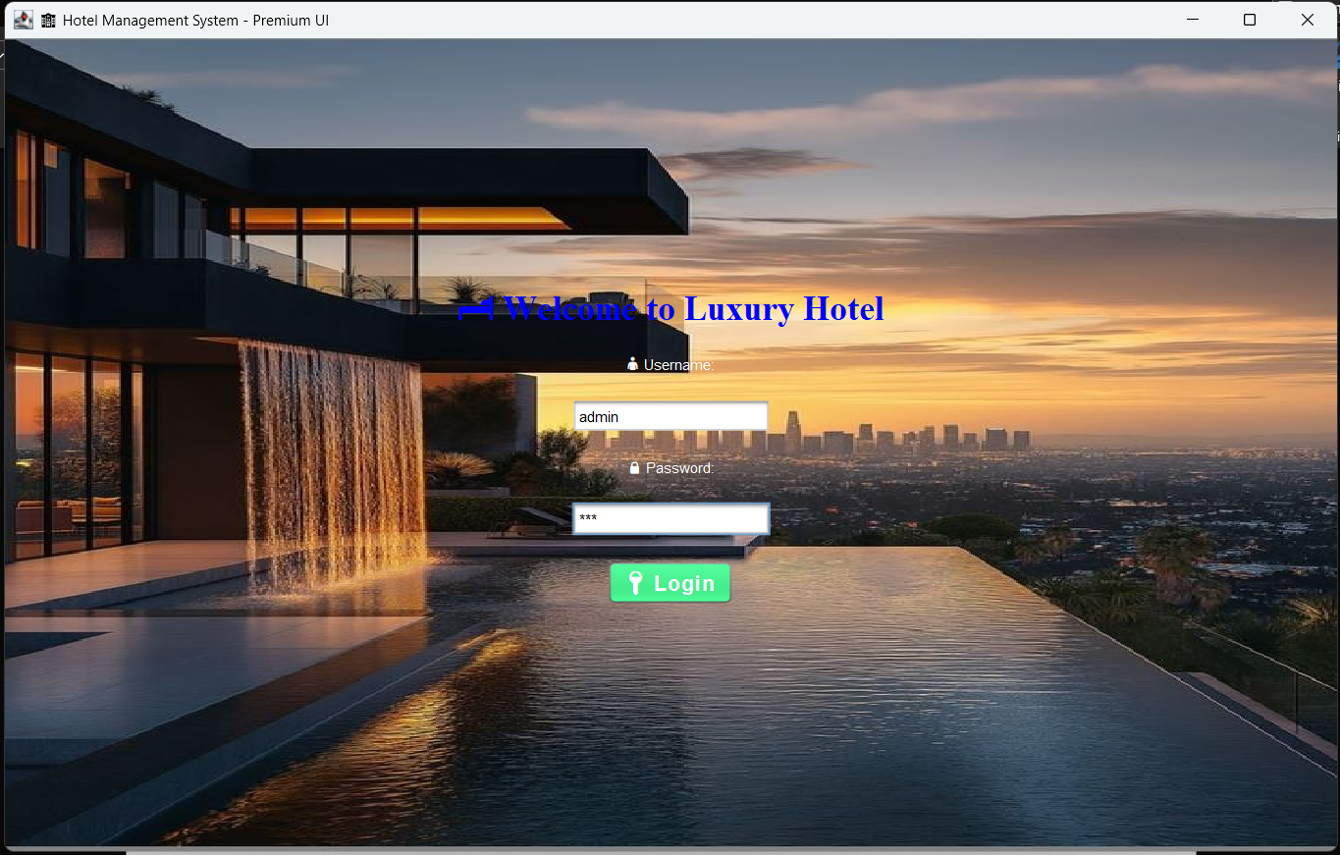

User interface:

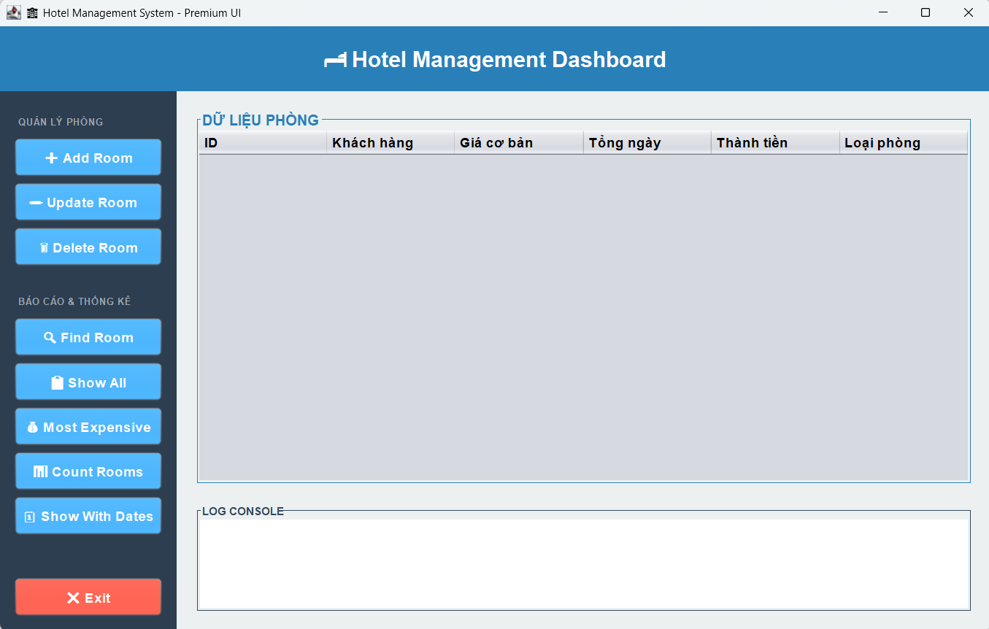

Add Room:
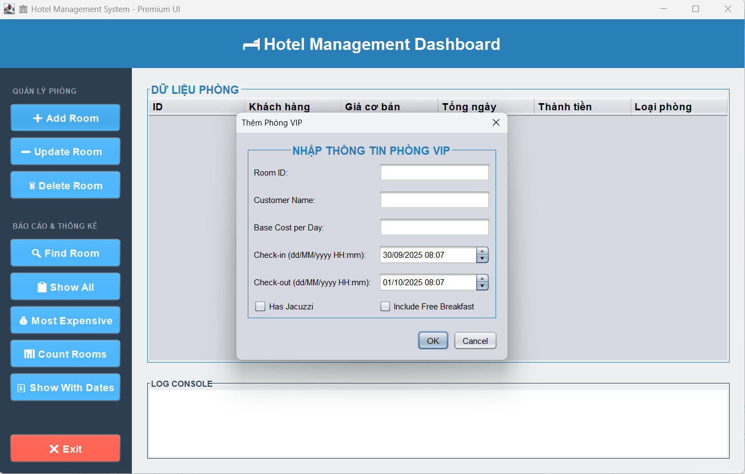

Display Room

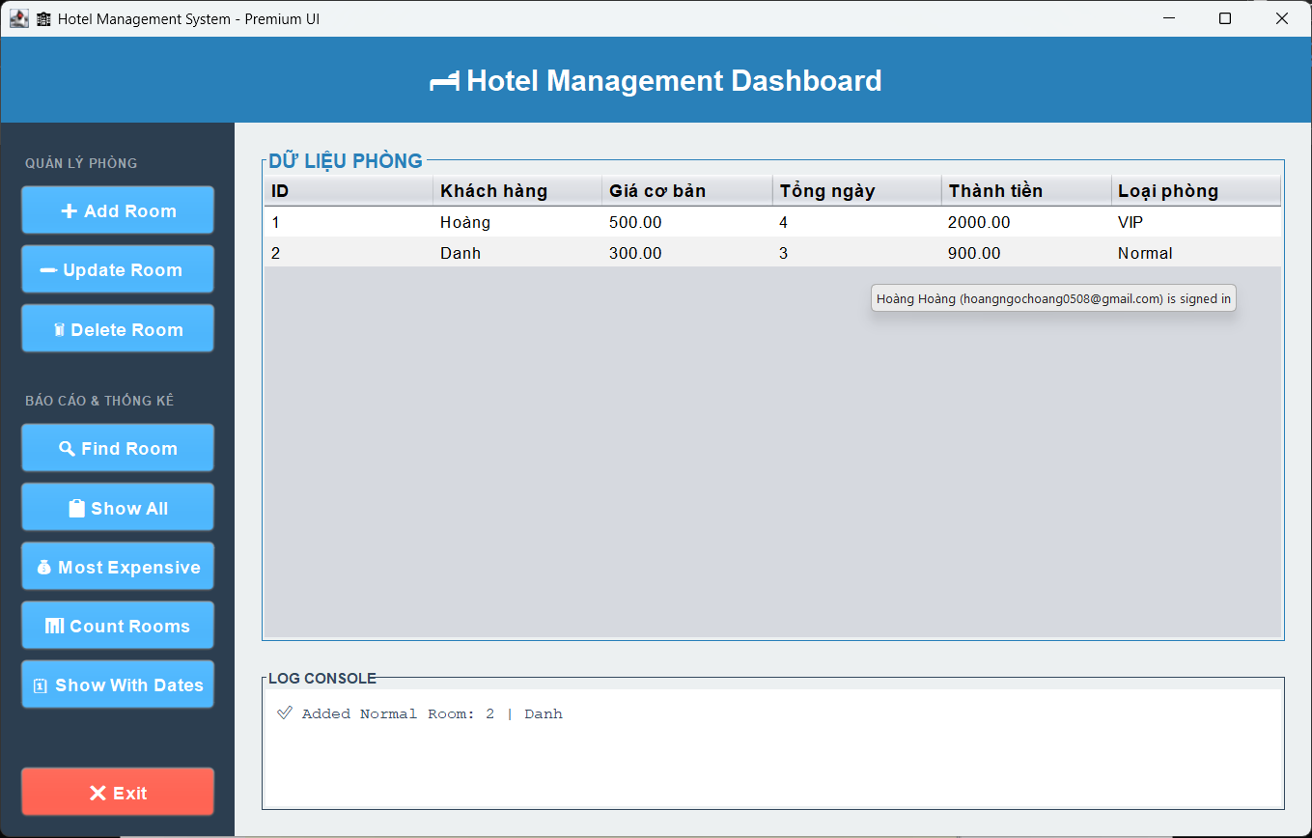

Most Expensive :

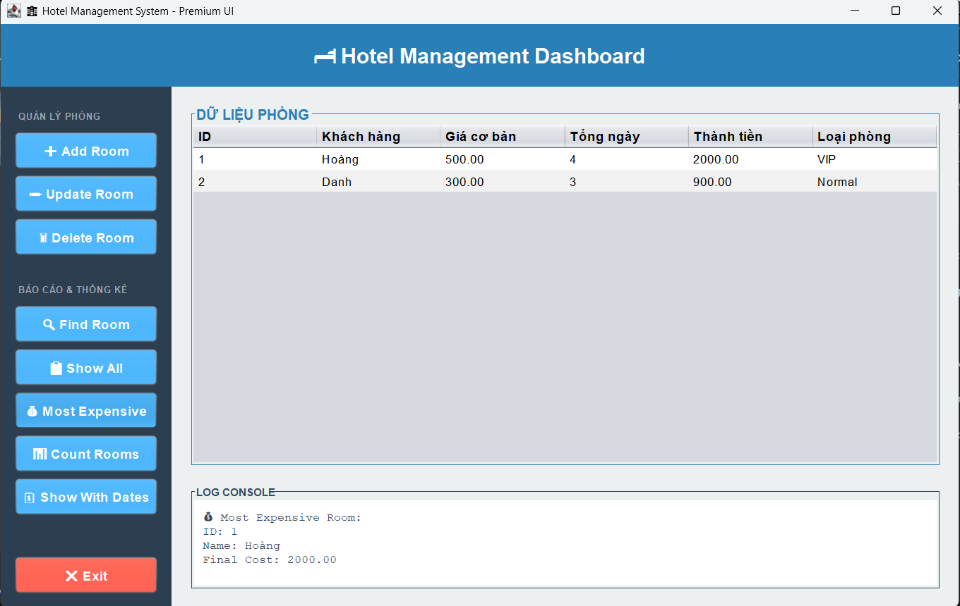

Count Rooms :
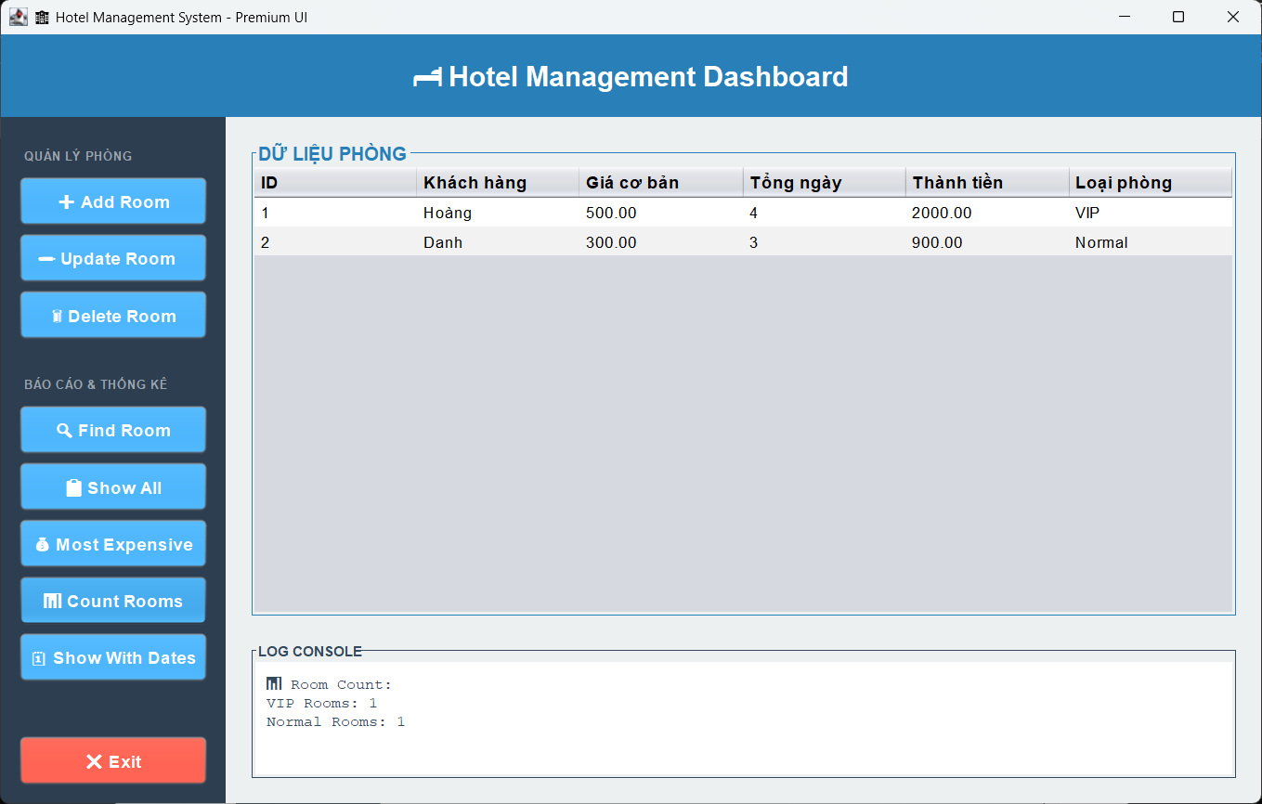

Delete Rooms :

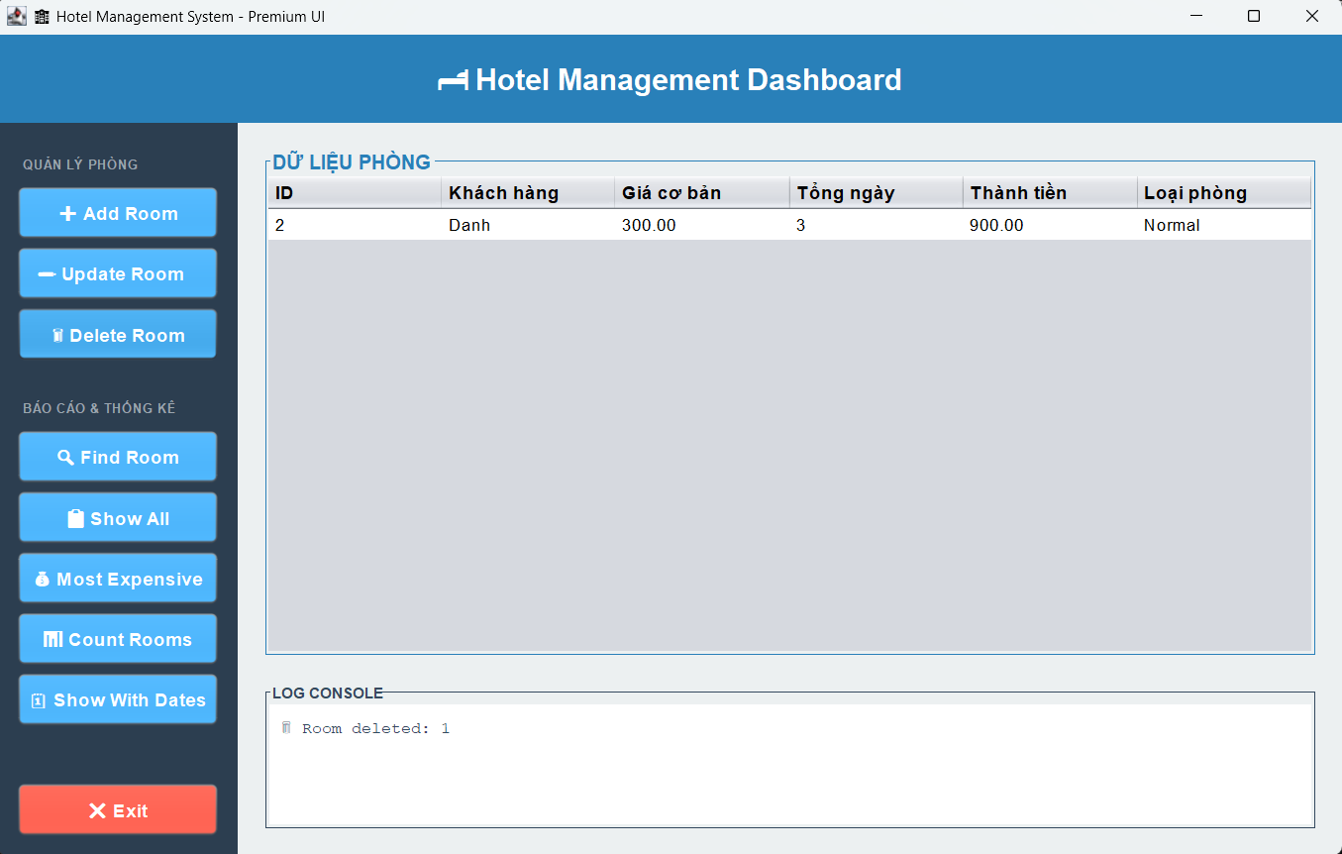

Update Rooms

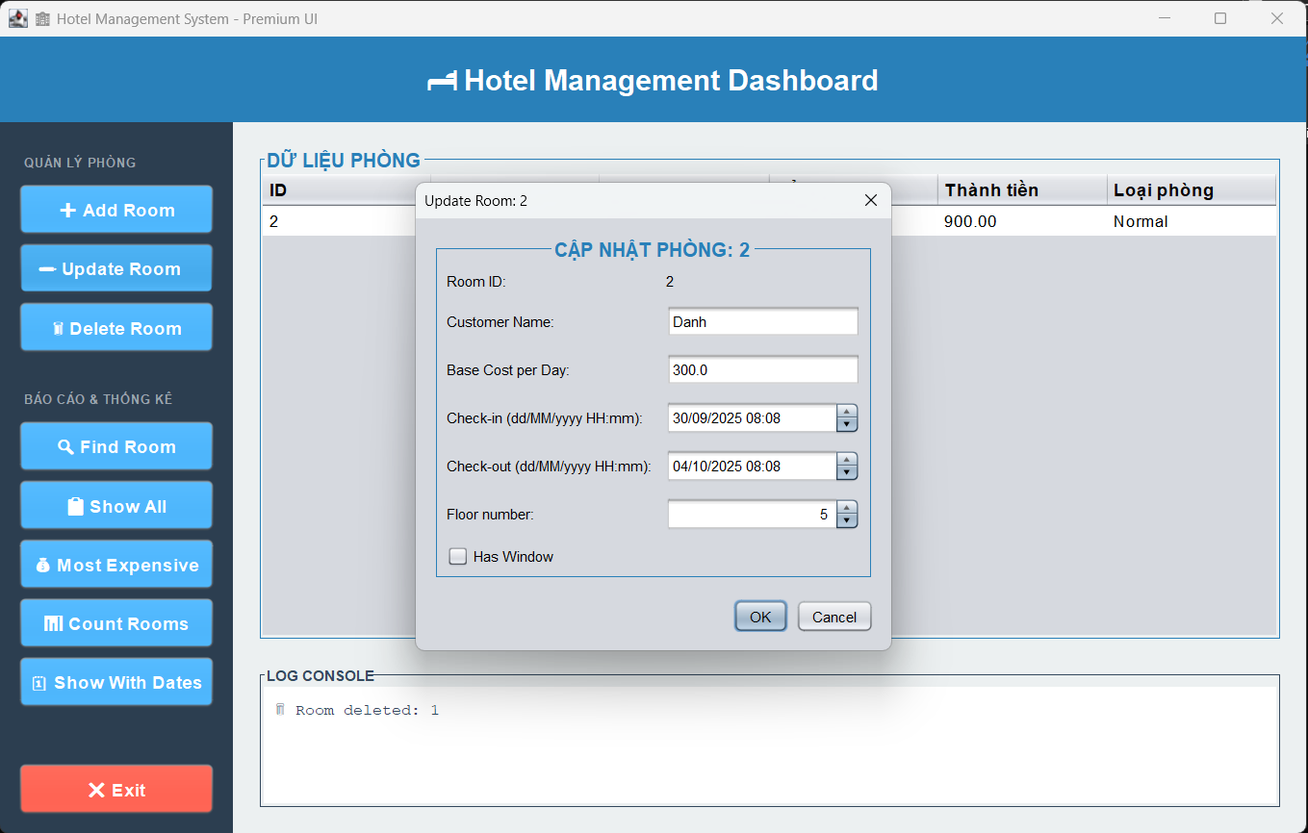

Find Room :

